Klapptest Flächenberechnung
Name:
 |  | Gegeben | Gesucht
Quadrat | 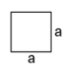 | a = 4cm | A = 16cm²  U = 16cm
Rechteck | 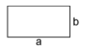 | a = 3,5cm  b = 1,25cm | U = 9,5 cm  A = 4,375 cm²
Parallelogramm | 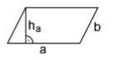 | A = 8cm²  h(a) = 2cm  U = 14cm | a = 4cm  b = 3cm
Raute | 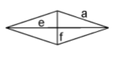 | a = 6cm  e = cm  f = 10cm | A = 5cm²  U = 24cm
Trapez | 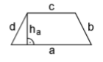 | a = 10cm  b = 5cm  c = 7cm  d = 5cm  h(a) = 4cm | U = 27cm  A = 34cm²
Dreieck beliebig | 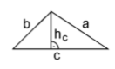 | c = 8cm  h(c) = 3cm | A = 12cm²
Dreieck rechtwinklig | 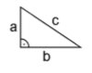 | b= 4cm  a= 3cm  c= 5cm | A= 6cm²  U= 12cm
Kreis | 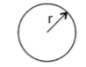 | r= 15 cm  d= 30 cm | A=708,86 cm²  U= 94,25 cm
Kreissegment | 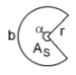 | a= 70m  r= 10m | A(Segment)= 14,10m  U= 23,68m

